How to Create a Portfolio

CLICK ON LIVETEXT DOCS

UNDER MY WORK, CLICK ON NEW

UNDER TEMPLATES, CLICK ON PORTFOLIOS

AFTER YOU OPEN PORTFOLIOS, CHOOSE BLANK PORTFOLIOS AND CLICK ON IT

ON THE RIGHTHAND SIDE, CLICK ON CREATE DOCUMENT
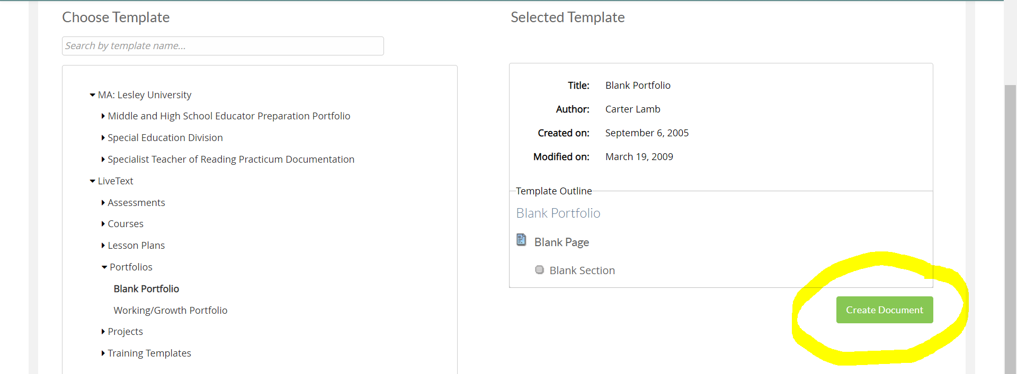

YOU WILL THEN BE ASKED TO PROVIDE A TITLE FOR YOUR PORTFOLIO. Press OK WHEN DONE.
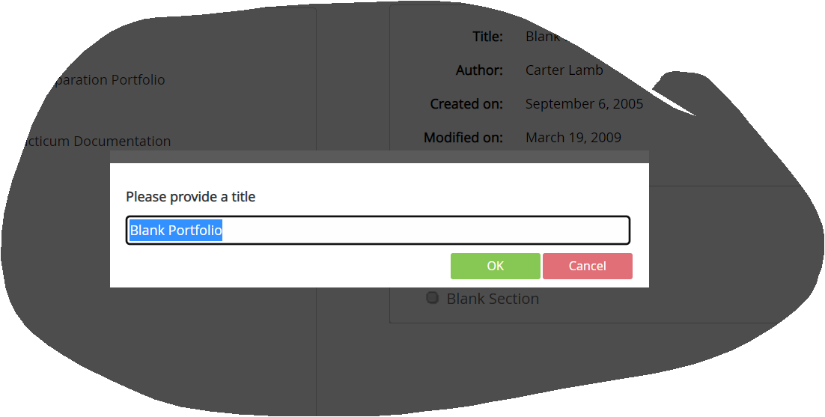
TO CREATE PAGES, CLICK ON MANAGE PAGES
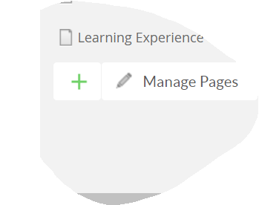
Then enter a title for the page:

TO ADD CONTENT TO A PAGE, CLICK ON THE GREEN PLUS SIGN

YOU WILL BE PROVIDED OPTIONS, CLICK ON TEXT AND IMAGE.

YOU WILL BE ASKED TO PROVIDE A TITLE FOR THAT SECTION:
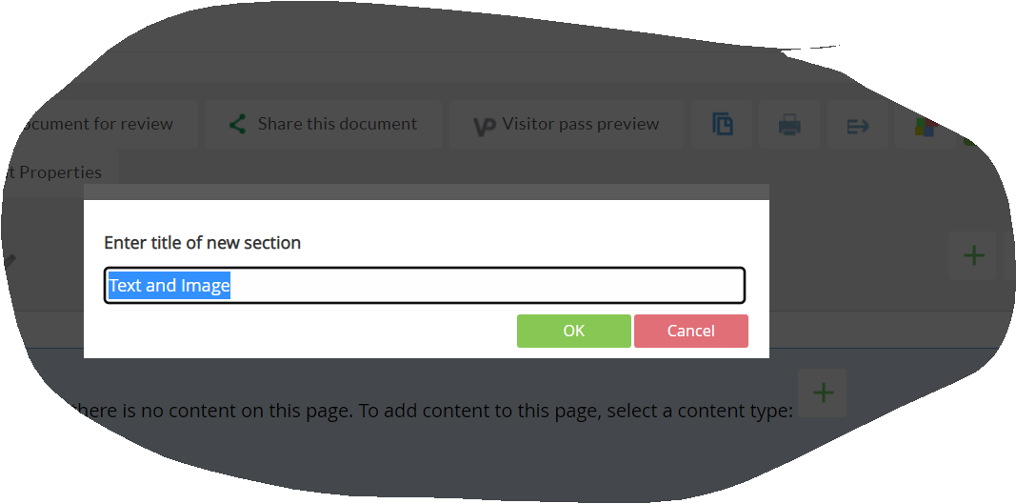

TO ADD CONTENT, CLICK ON EDIT

THEN, YOU CAN INSERT IMAGES, FILES AND VIDEOS. YOU CAN ALSO TYPE IN TEXT. WHEN YOU ARE DONE, MAKE SURE TO CLICK SAVE &FINISH
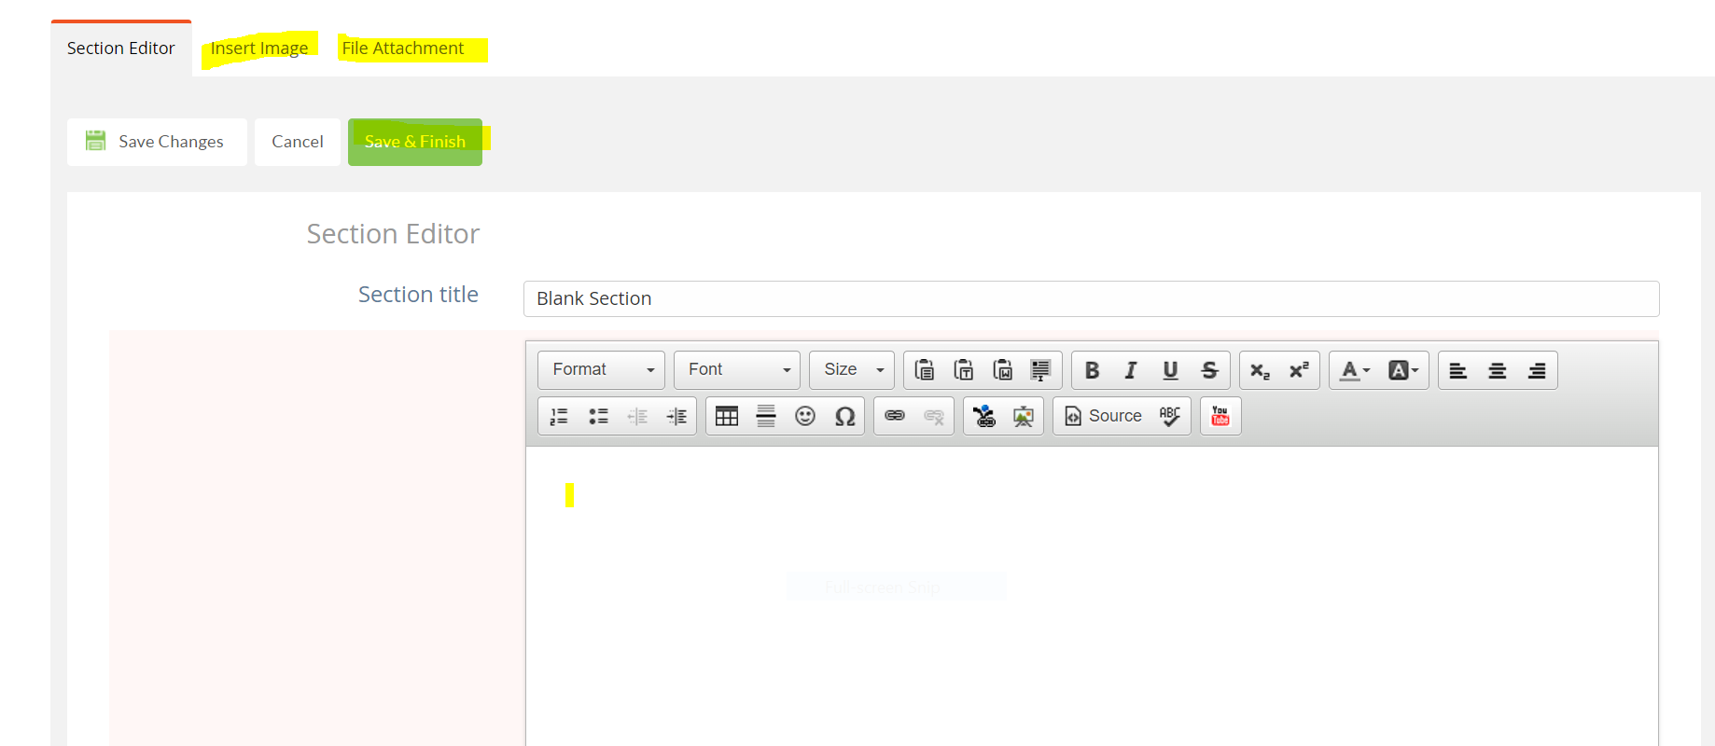

TO CREATE ADDITIONAL PAGES, go back to Manage Pages and click the green + sign to add more pages:

THEN, FOLLOW THE SAME DIRECTIONS YOU FOLLOWED FOR THE FIRST PAGE YOU ADDED.

ONCE YOU ARE DONE, EVERYTHING WILL BE SAVED IN LIVETEXT DOCS. You can open and edit your portfolio here at any time.

